**DNS SERVERS**

DNS stands for Domain Name System.

Computers identify each other by numbers called IP addresses over a network.

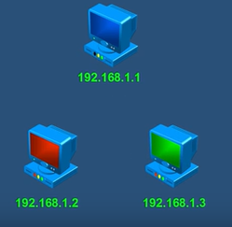

Hence, for computer users to communicate with other computers in a network, IP addresses have to be remembered and used. Since it is easier for humans to remember names than numbers, DNS servers are used.

* Without DNS server

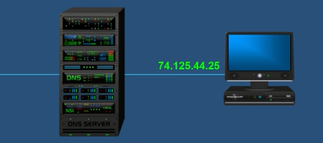

Suppose this computer wants to reach the yahoo webpage. Instead of typing yahoo.com in the web browser, we can directly type the IP address to retrieve the webpage.

* With DNS server

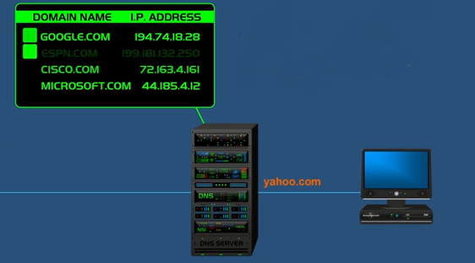

Now, if yahoo.com is typed in the web browser, the computer cannot connect to the yahoo server since the IP address is not known. In this case, the domain name (here yahoo.com) is sent to the DNS server. The DNS server stores domain names and the matching IP addresses. The server finds the IP address of yahoo.com and this IP address is sent over the network.

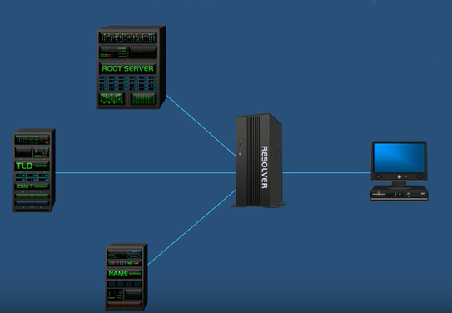DNS SERVERS IN FURTHER DETAIL

When you type yahoo.com in your web browser, the computer checks its own cache memory for the IP address of the yahoo webpage. If it is not found, the domain name goes to the resolver (or the ISP). The resolver checks its own cache memory for the IP address. If it is not found, the query goes to the root server.

Now, the root server does not know the IP address. Instead, it directs the resolver to the Top Level Domain Server (or TLD server) by providing its IP address. The TLD servers store address information about top level domains. Examples of top level domains are .com, .net, .org and so on.

Since the query was yahoo.com, the root server directs the resolver to the TLD server that manages the .com domain.

The TLD server also does not know the IP address. It directs the resolver to the Authoritative Name Server. This server knows everything about the domain, including the IP address. So, when the resolver asks this server, the server responds with the IP address of yahoo.com. The resolver sends the IP address to the computer. Both the resolver and the computer store the IP address in their cache memories for future use.